FACULTY EVALUATION
Programme Name: SEP Scale Alumni Masterclass Module 1 Tanzania (11th May 2026 - 15th May 2026)
Session: Reflection of SEP Learning
Faculty Name: Dr. Isaac Muiruri Gachanja
No. of Respondents: 19
No. of Participants: 19
Evaluation Parameter | (%) Individual Score | (%) Programme Average
Punctuality (Commencement and Completion of Sessions) | 77 | 92
How well do you understand the core concepts presented? | 81 | 88
Rate your confidence in applying the new skills learnt | 82 | 85
Degree of Faculty preparedness for the sessions | 81 | 90
Content and methodology of the program | 84 | 90
Quality of class and group discussions | 82 | 89
The information presented in the course is relevant to my work (ministry) | 87 | 92
Average scores | 82 | 89

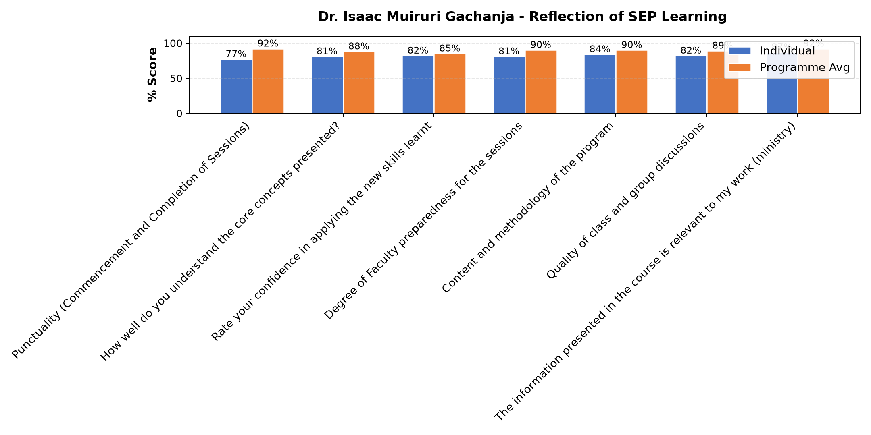

Comments & Feedback
- • Network
- • Network problem sometimes I didn't get well the discussion
- • Lack of money become a big barrier in running Instution.
- • Network were not stable
- • Some times a network.
- • Lack of sufficient resources to improve our project, Challenges in obtaining technology or network services. And also Difficult business environments such as competition or economic challenges. But I am very grateful for this education we received that we continue to use and it brings us greater benefits.
- • The major challenge that might prevent me from applying what I have learnt is how to accomplish the SE goals within a limited budget. The world moves so quickly but for us who live in the villages we are still very far. At the same time we need to move with signs of time. Now, how do we move with time without enough capital?
- • Fear of taking risk
- • There is no barrier
- • Lack of enough resources or materials
- • Poor response from the donours
- • Lack of getting enough chicks in timeMr
- • I learn on how to manage ECONOMIC INTERPRICES
- • Economic factors
- • Barriers which could hinder or prevent us from applying what we learned might be lack of enough chicks and deases which always appear.
SUBMITTED THROUGH:
SBS Evaluation Automation System

